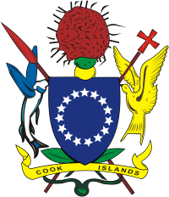 

MINISTRY OF INTERNAL AFFAIRS

**Social Impact Fund (SIF)**

**Project Funding**

The Cook Islands Social Impact Fund (SIF) is a contestable

fund administered by the Ministry of Internal Affairs and

financed by the Cook Islands and New Zealand Governments

until June 2016. Registered Cook Islands Civil Society

Organisations can apply to SIF for funds to deliver services to

vulnerable groups in 3 areas: Gender equality (including domestic

violence), Children and Youth, and Disabilities (including mental

health, physical health and care for the elderly).

For further inquiries please contact the SIF Manager on

Telephone: 29378 or email: [angeline.tuara@cookislands.gov.ck](mailto:angeline.tuara@cookislands.gov.ck),

[www.intaff.whupi.com](http://www.intaff.whupi.com), Ministry of Internal Affairs.

Closing date for Project Funding Application is Friday

25 September 2015. No applications will be accepted after this date.