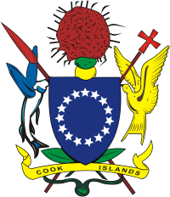 

MINISTRY OF INTERNAL AFFAIRS

**EXPRESSION OF INTEREST (EOI)**

**Social Impact Fund (SIF) Board Member**

EOI’s are now invited from CSO’s, Private sector

and Individuals who wish to be considered for the

above. There are 3 positions available for one year.

For further inquiries please contact the SIF Manager on

Telephone: 29378 or email: [angeline.tuara@cookislands.gov.ck](mailto:angeline.tuara@cookislands.gov.ck)

Ministry of Internal Affairs [www.intaff.whupi.com](http://www.intaff.whupi.com).

Closing date for Expressions of Interest is Wednesday

9 September 2015.